Digital and Technology – Autopilot Checklist – New Device
Technician completing Autopilot: | {dispatch_user} | Date: | {dispatch_date}

Requirements:
- Bootable USB key, with latest Windows 11 OSDCloud image.
To create, follow the instructions in TSO Guide – Create a USB Bootable Disk for Windows 11.docx
- CA or A prefix account for Intune.
- Wired network connection for the device being imaged.
Need help? Use the MWP + ITSOs Teams chat, and provide all of the following information:
- Service Tag/Serial Number of the impacted device;
- Which step of this checklist the issue occurred at;
- Full details of any errors displayed (i.e. Screenshot/Photo, Error Code, full Error Text); and
- Specific troubleshooting steps you have already performed.
Note: The term Service Tag is used interchangeably, and should also be taken to mean Serial number where imaging a non-Dell device (WOW, Endobase, etc).
On the TSO Device: | Done?
- Save a copy of this document with name “AP Checklist ServiceTag_DDMMYY” in the SharePoint folder: Autopilot checklists > Your State-Your Site Code (i.e. WA-MI) | ☐
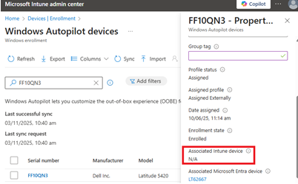  - Obtain the device’s service tag, and verify its Autopilot enrolment status:  - Navigate to Intune > Devices > Device onboarding > Enrollment > Windows Autopilot Devices  - Search for the Service Tag, then click on the Serial number to view the device Properties blade.  Note: If you cannot find the device via search, follow TSO Guide: Obtain and Upload the Autopilot Hash for Intune Enrollment, before repeating Step 2(b).  - Ensure the field Associated Intune device displays N/A .  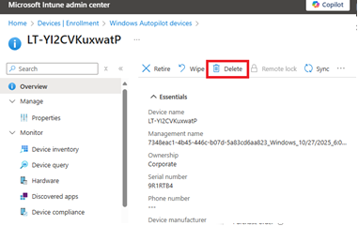  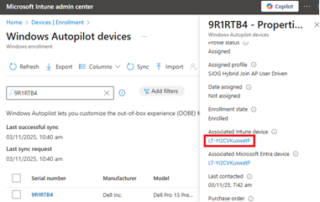  - If the field Associated Intune device is not N/A, then click on the device name shown in this field to access Device Overview. Once loaded, press Delete to delete the Intune device.  Note: TSOs lacking permissions to delete an Intune device must post a delete request with the service tag in the MWP + ITSOs Teams chat. | ☐
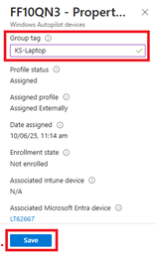  - Staying in the Autopilot Device properties blade, add the Group tag to the device.  Enter the Group tag in the format of:  sitecode-devicetype  For example: KS-Laptop, MI-Desktop  Once entered, press Save at the bottom of the Properties blade. | ☐
- Go back to the Windows Autopilot devices screen, then obtain and copy the Entra Device ID.
- Enter the Service Tag.
- Click on the Service Tag in the results to view the Properties blade.
- Scroll down and click on the link under Associated Microsoft Entra device.
- Press the Copy button at the end of the Device ID field.
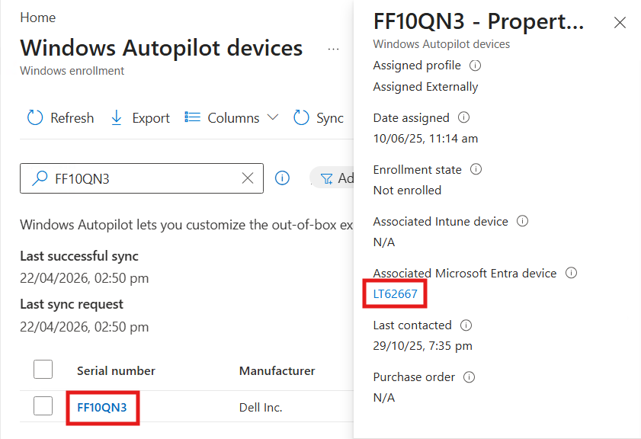
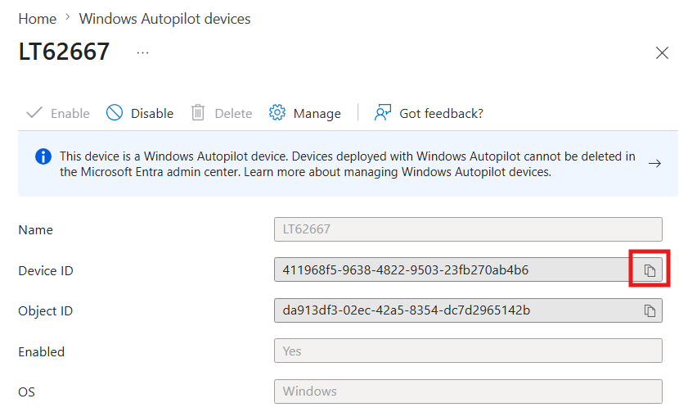
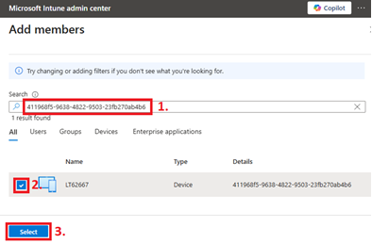  - 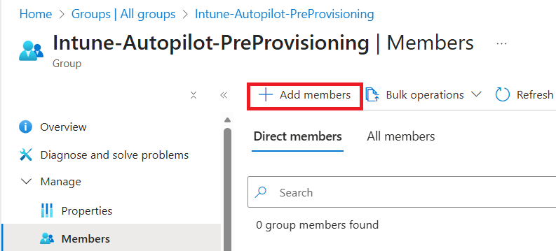Staying in Intune, navigate to Groups > Intune-Autopilot-ESP-Prod, then press Add members to add the Entra Device ID (Step 4) to this group. | ☐
On the new device: | Done?
- Connect the device to the Wired network. For laptops, ensure you connect the device to a Dell Docking Station (needed for network connectivity due to drivers).
- For new devices not running Windows 25H2: Follow TSO Guide – Install Windows 11 Using USB Bootable Disk to install Windows 11. The device should restart at the end of the imaging process. | ☐
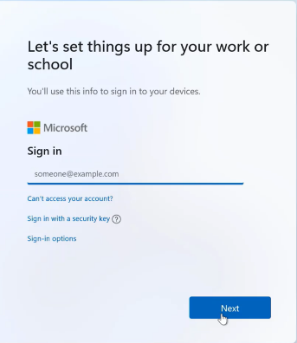
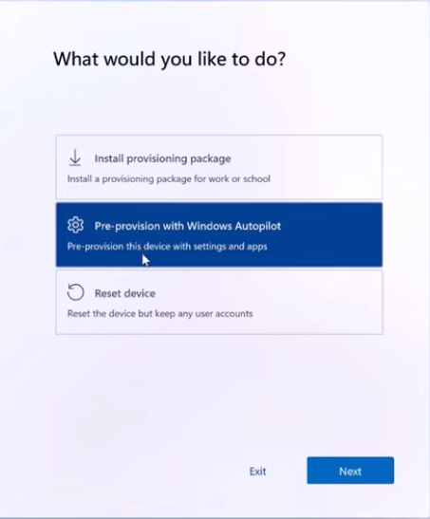
- At the screen Let’s set things up for your work or school - press the Windows key five (5) times.
When on the “What would you like to do?” screen, press Pre-provision with Windows Autopilot, then press Next.
A Checking for updates screen will now appear, and when completed - it will proceed to the pre-provisioning screen in Step 10.
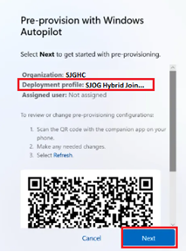  - On the Pre-provision with Windows Autopilot screen, verify that SJOG Hybrid Join is shown as the Deployment Profile, and if correct - press Next.  If Deployment profile name is not correct: press Cancel, repeat Steps 2-5, then return to Step 9.  Wait for the device to complete preparation and setup.  Note: Keep track of progress by pressing the arrow next to each section of this screen, to assist with troubleshooting and diagnosing Autopilot failures. | ☐
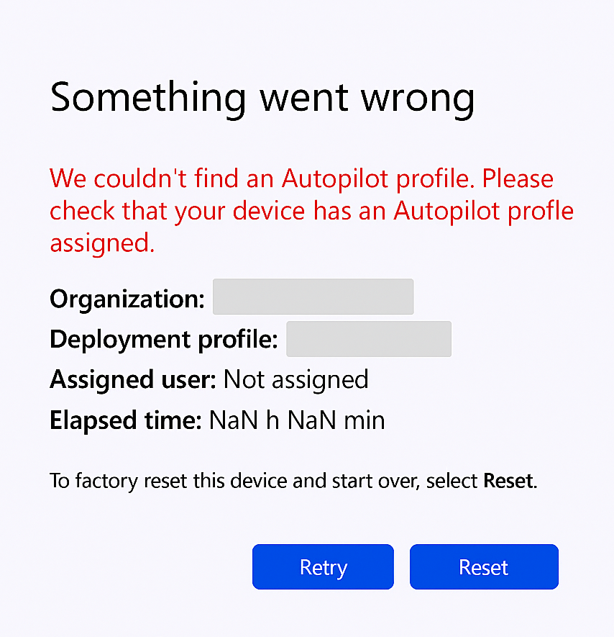
- If your device fails to Autopilot, you must press the Reset button to try again AND then reimage the device by USB key.
Ensure you verify 1) Associated Intune device is deleted, and 2) Userless Enrollment Status for the device (shown at Intune > Windows Autopilot Devices) is set to Allowed. If set to Not Allowed, select the device, and press Unblock device from the menu.
Wait 2min and refresh to confirm Allowed is displayed before proceeding.
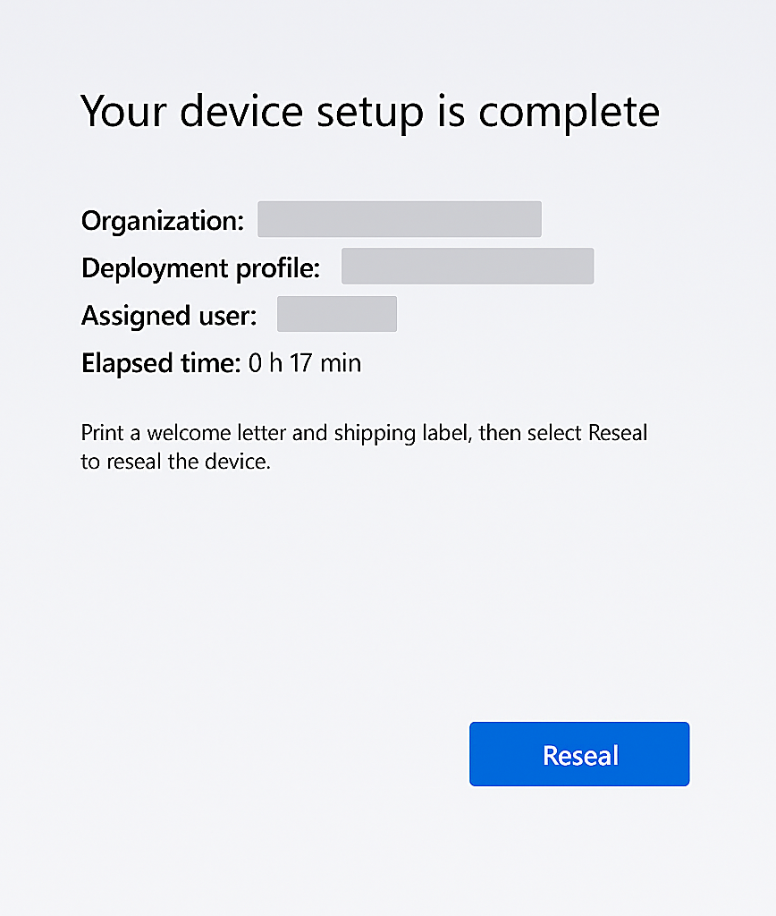  - At the Your device setup is complete screen, press the Reseal button in the bottom-right of the screen.  The device will now shut down. | ☐
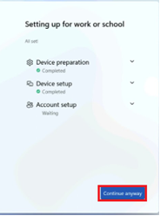
- Power up the device being imaged.
The Setting up for work or school screen will now appear.
If an error appears, press the Continue Anyway button in the bottom-right of the screen.
Leave device at the Windows login screen.
On the TSO Device: | Done?
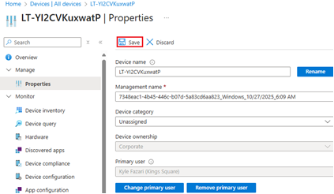  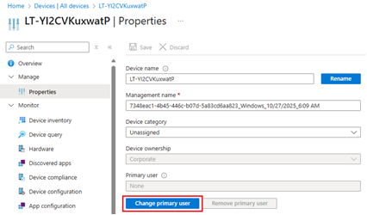  - Ope Intune, and navigate to the Devices screen. Search for the device being imaged using its Service Tag, then click the Serial Number to select its record.  Navigate to the Manage > Properties page, and press the Change primary user button. Set the Primary user to your E or C prefix account.  Press the Save button after changing the primary user. | ☐
- Staying with the Device Properties page, return to the Overview page, and copy the Device Name. Navigate to the group Intune-Autopilot-ESP-Prod, to search for and remove this device from this group. | ☐
On the new device: | Done?
- Login to the new device for the first time.

- Open the Company Portal app, then check that all required applications are installed.  Install only one (1) app at a time, and in the following order, to prevent any failures:  - Cortex XDR Windows x64  - Office (If a shared device, Install Office 2016 Pro Plus to replace standard version)  - (Dependency for next app) - Microsoft .NET Desktop Runtime 8 8.0.21.35325  - Dell Command | Update  - (Dependency for next app) - Microsoft Edge WebView2 Runtime 142.0.3595.53  - Zenworks Agent  - Laptops only: Global Protect  If installing from a USB image: Most applications required for a Standard workstation are already installed – but you must check and verify every required application has been installed. | ☐
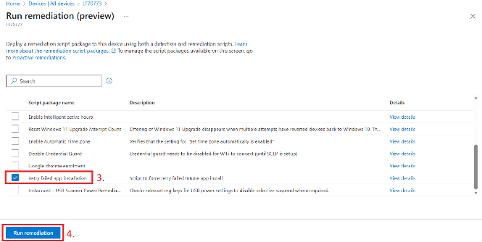  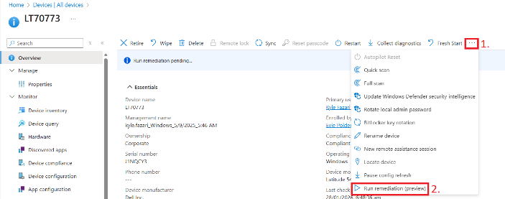  - If an application install from Company Portal is failing, navigate to Intune > Devices, search for the device, then from the three dot (…) menu, select Run Remediations > Retry failed app installation, before proceeding. | ☐
- Run Dell Command | Update, to ensure all BIOS and driver updates are installed. | ☐
- Follow all PCL’s/documentation for any other software or actions needed for this device. Examples include – but not limited to: Imprivata; Host Name for WA Health HSS Whitelisting; | ☐
- When all Dell Command updates have been installed (including any required reboots), power off the device.
On the TSO Device: | Done?
- In Intune, open Devices, to search for and select the device being image. Then from the Properties page – press Change primary User, and change the primary user to either the assigned Caregiver (if an assigned device), OR the Unit/Area Manager (if a shared device), then press Save. | ☐
- CRITICAL STEP: ZENworks, navigate to Devices > Device List, then search for and select the Old device. Click on Actions > Copy Relationships, to copy the relationships from the old device to the new device.  If not replacing a machine, Copy Relationships from an existing device used within the installation location for the same/similar type(s) of activities.  Finally, ensure the device is in the correct group folder for the device type and location, and change if incorrect.  Once complete, perform a Zenworks Refresh from the target device to ensure all expected applications are showing within the Zenworks window. | ☐
- Search for and open the CMDB record (using device name or service tag; OR create new record if not found by device name or service tag), and ensure all of the following information is updated and accurate for this device:  - Device name (only if creating a new record)  Full device name as shown in Intune (i.e. LT-kOVyla8ylpM7)  - CI  Enter only the Numbers from the SJGHC Configuration Item sticker.  - Assigned to  E number for the assigned caregiver, OR Unit/Area Manager if a shared device.  - Site  - Department  Full department name/ward name, acronyms should not be used. Examples:  Head Of Department Surgical; Ward 2B; St Thomas Ward; Admissions  - Floor-Room  Format: Building Number/Letter, Compass Direction, Floor Number, Room Number (where displayed next to room at site), and Room Name/Descriptor. Examples:  - Building B Floor L1 Room 15.235 Nursery;  - Floor G North Block Room 1.123 Security Manager  - Floor 4 Room 5.459 Ward 4A East Nurses Station;  - AND If this device replaces one that will be decommissioned/disposed:  - Update Downstream CI: Add a note to both the new, and old device, referencing the replacement CI and the replacement date. | ☐
- Work with the Caregiver/Manager to install new device; and if this device replaces one that will be decommissioned/disposed – without exception, you must:  - Collect old device at the same time as installing this new device, and  - Before COB of the current business day, complete all disposal/decomissioning PCL or associated directions, steps for the old device.  Assist caregivers where reasonable to support immediate collection of old devices.  You must not a) allow a caregiver to retain any device(s) for decommissioning or disposal under any circumstances; and b) install new devices until the old device can be collected. | ☐
- Ensure old device details are immediately added into your local disposal register, and place device in disposal storage location for future collection. | ☐

